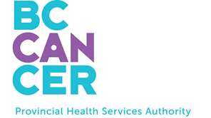

Head & Neck Support Group



These monthly sessions provide information, ideas for coping, and time to connect and share experiences with others.

Patient & Family Counselling Services
Support groups

1st Thursday of each month, 10:15-11:45
Online via Zoom for Healthcare
Facilitated by Laura Daly, Clinical Counsellor

Registration required
Please call 250-519-5525

